📈 Stock Data Analysis Report
1. Introduction
This project analyzes stock market data to uncover trends, volatility, and performance metrics. By applying statistical methods and visualization techniques, the study aims to support investment decisions and highlight market behavior over time.
2. Dataset Overview
- Attributes: Date, Open Price, Close Price, High, Low, Volume, Adjusted Close.
- Target Use: Time-series analysis of stock performance.
- Size: Daily records across multiple companies or indices.
3. Objectives
- Explore historical stock price trends.
- Detect volatility and outliers in trading activity.
- Compare performance across different companies or sectors.
- Visualize moving averages and technical indicators.
- Build predictive models for short-term price forecasting.
4. Tools & Libraries
- Python – core programming language
- Pandas & NumPy – data manipulation and numerical operations
- Matplotlib & Seaborn – visualization
- Scikit-learn / Statsmodels – statistical modeling and forecasting
- Jupyter Notebook – documentation and reproducibility
5. Key Analyses
- Exploratory Data Analysis (EDA):
  - Distribution of daily returns.
  - Correlation between stock prices and trading volume.
- Outlier Detection:
  - Identify unusual spikes in price or volume.
- Visualizations:
Box plot: Daily Price Range Distribution by Ticker compares the volatility of four major stocks: AAPL, MSFT, NFLX, and GOOG.
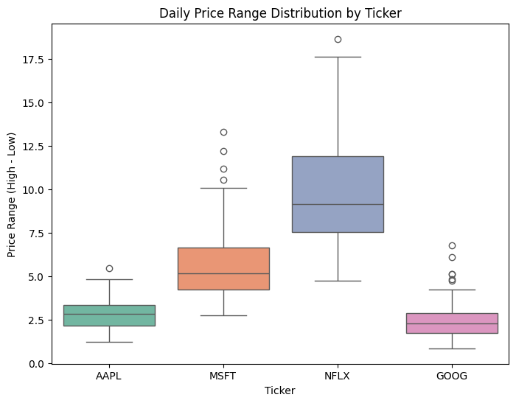

Line graph: Closing Prices Over Time tracks the stock performance of AAPL, MSFT, NFLX, and GOOG between February and May 2023.

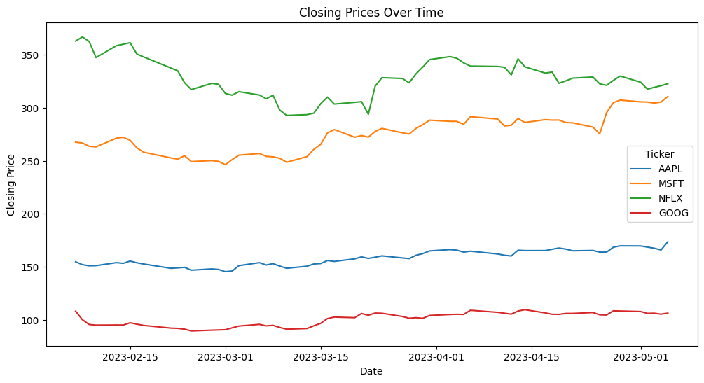

Heatmap: Correlation Matrix of Stock Features shows the relationships among key market variables: Open, High, Low, Close, Adjusted Close, and Volume.
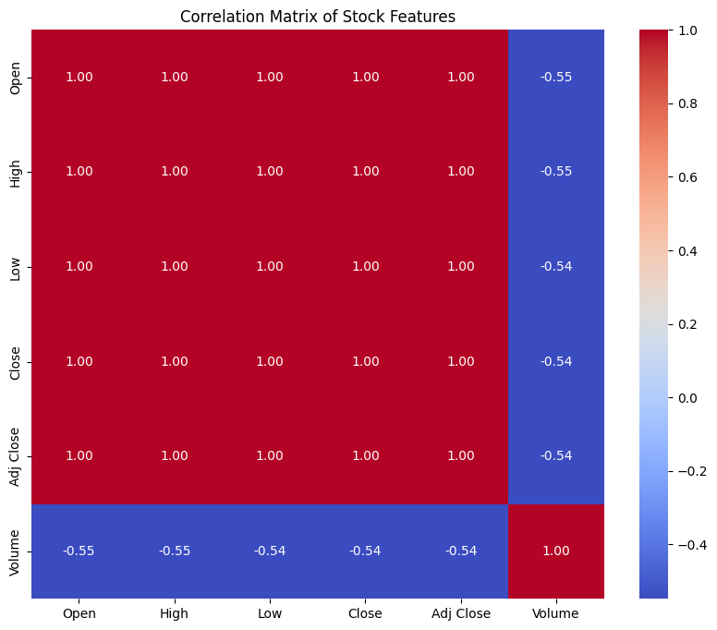

Pair plot (scatterplot matrix) : visualizes relationships among stock features: Open, High, Low, Close, and Volume.
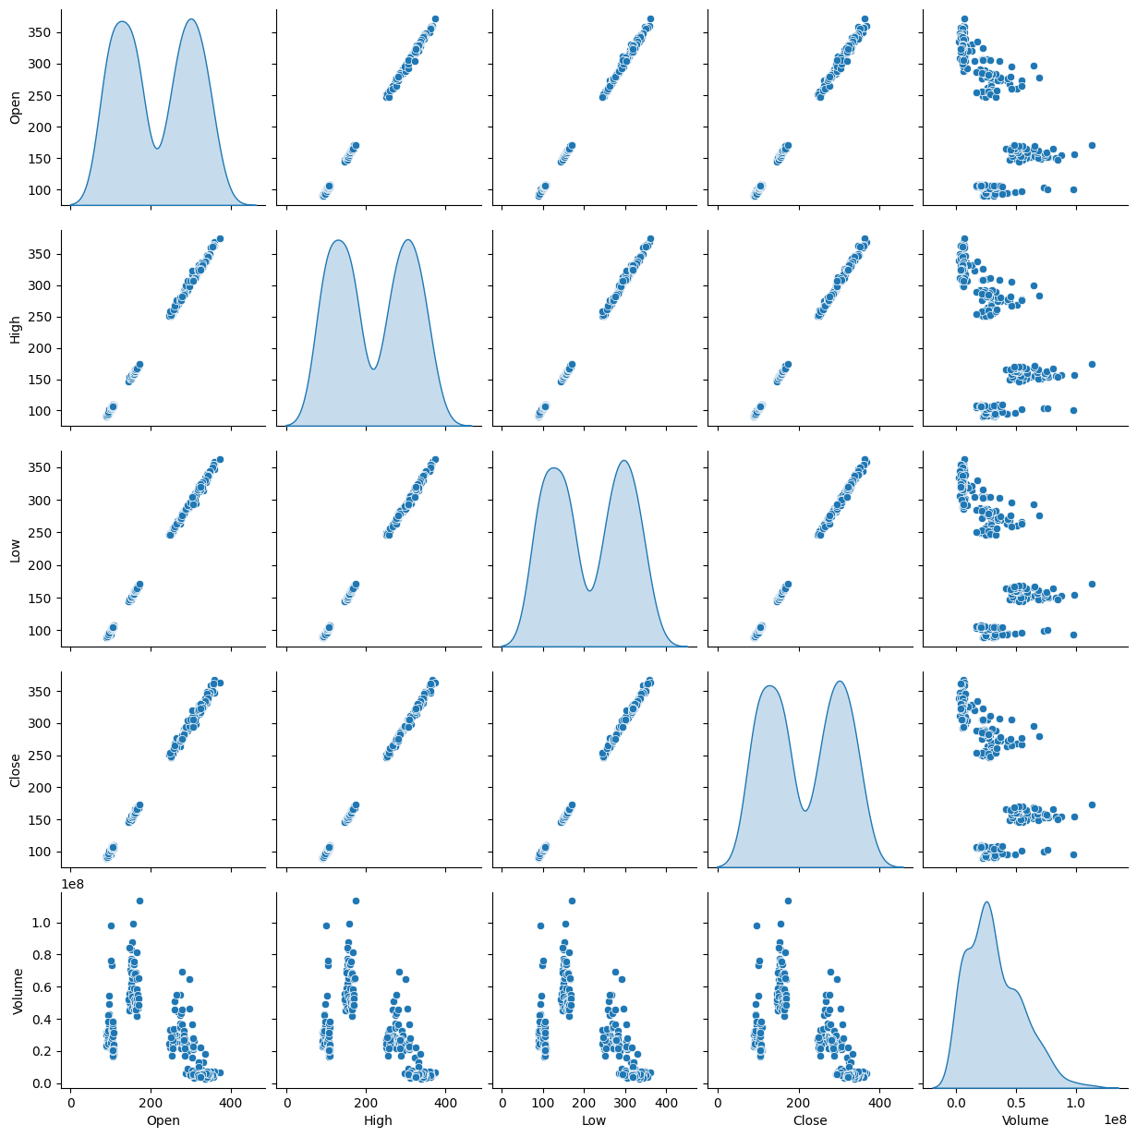

6. Insights
- Moving averages reveal long-term growth trends.
- Volatility analysis highlights periods of market instability.
- Correlation studies show sector-level dependencies.
- Predictive models provide short-term guidance but require caution due to market uncertainty.
7. Conclusion
This analysis demonstrates how stock data can be leveraged to understand market dynamics and support investment strategies. Combining statistical methods, visualization, and predictive modeling provides actionable insights for traders, analysts, and stakeholders.

